## **Youki Iimori**

## Project 3 Check-off

## **Due: END OF DAY TODAY (Tuesday, November 6) at 11:59 pm**

**Place an X in the box that describes your level of progress on each of the following tasks below.**

|  |  |  |  |  |  |
| --- | --- | --- | --- | --- | --- |
|  | Done! ☺ | Almost finished | Some progress | A little progress | Have not started |
| Humans are instantiated into scene | X |  |  |  |  |
| 1 (or more) zombie is instantiated in scene | X |  |  |  |  |
| Zombie finds closest human |  | X |  |  |  |
| Zombie seeks closest human |  | X |  |  |  |
| Humans are moving somehow (maybe seek a moving target?) |  |  |  |  | X |
| Human determines a zombie is within range |  |  | X |  |  |
| Human flees from the closest zombie (in range) |  | X |  |  |  |
| Debug lines are drawn for forward, right vectors |  |  | X |  |  |
| Debug line drawn from zombie to closest human |  |  | X |  |  |
| Collisions between Human and Zombie detected | X |  |  |  |  |
| Human turns into a Zombie when bitten | X |  |  |  |  |
| Humans and Zombies stay in the park |  |  |  |  | X |

**Add code snippets and screenshots here:**

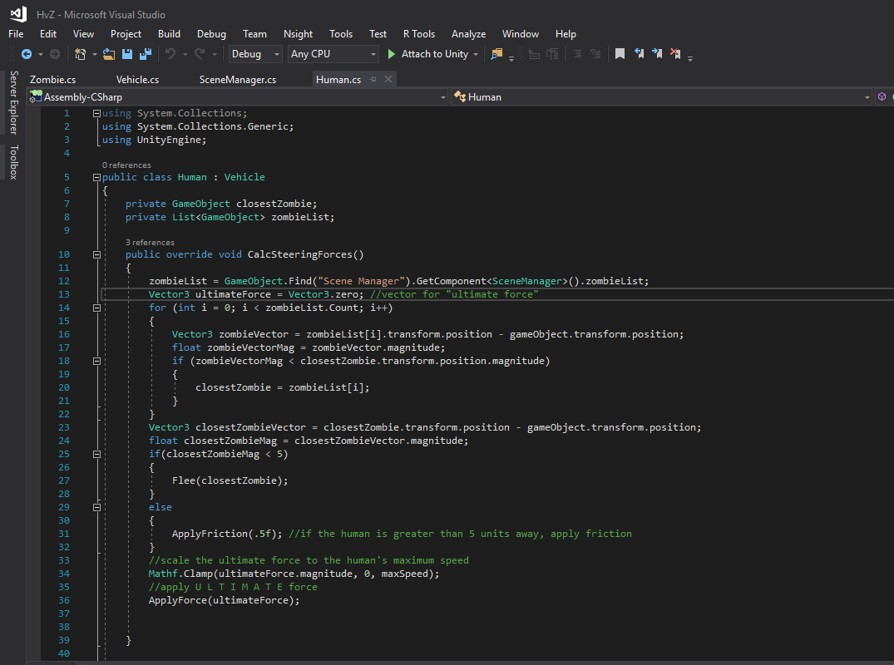

**Code for my humans, specifically calculating the steering forces to get away from whatever the nearest zombie is. It’s currently not complete, requiring a default value for closestZombie to work.**

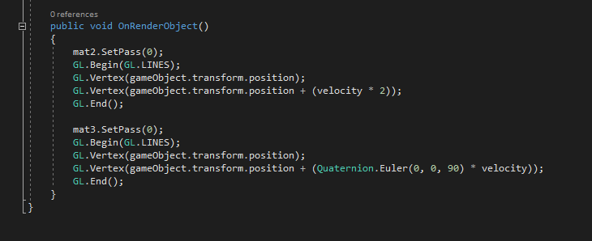

**Code for debug lines for the human, this WAS working but I don’t think it is anymore… not after the changes made to accommodate multiple zombies.**

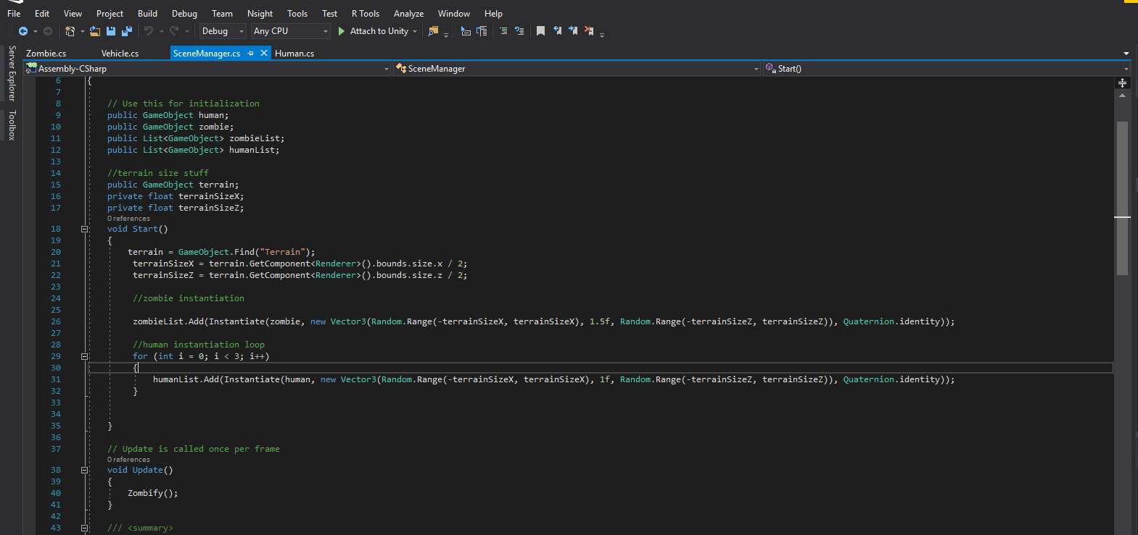

**Screenshot of my scenemanager script, it’s there to spawn in zombies and humans as well as manage collisions/zombie transformations.**

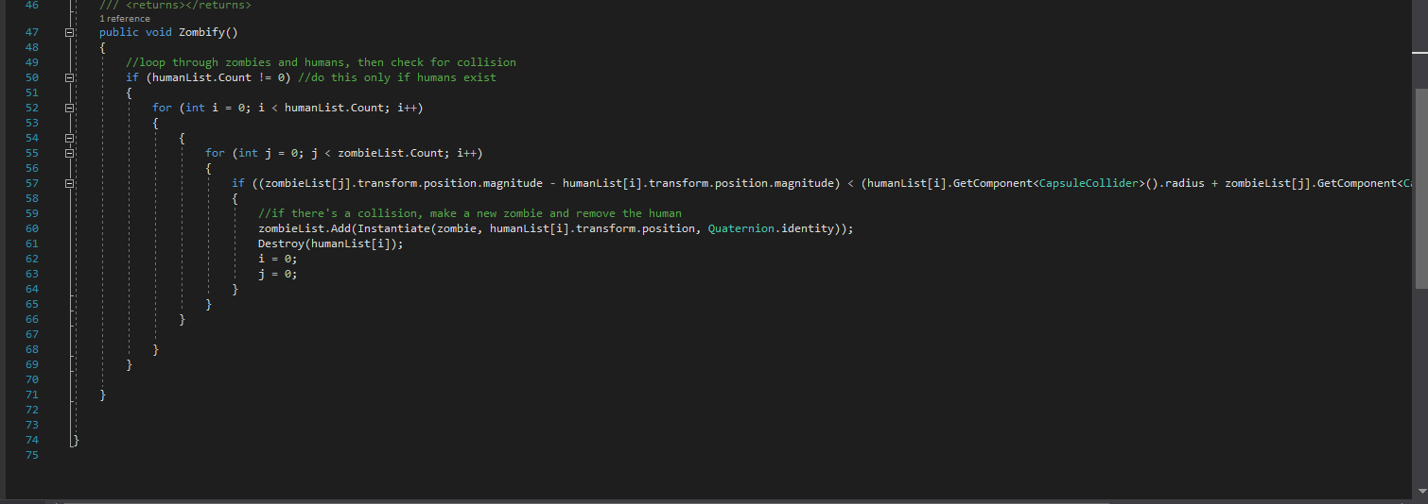

**Also on my sceneManager script, this is the code I plan on using to zombify my humans. It’s CURRENTLY working.**

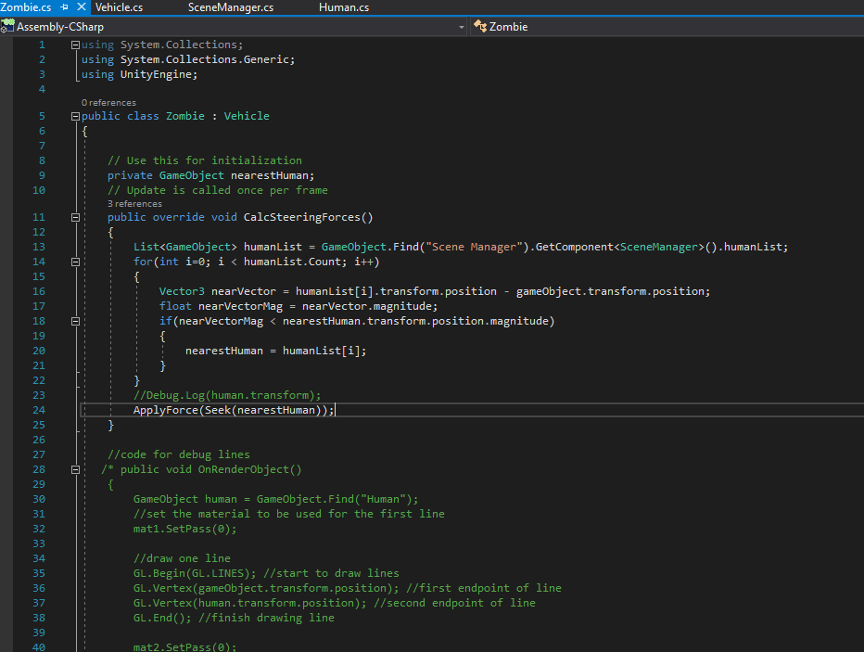

**This is the bulk of my zombie script, I’m working on getting it working right now. It compares the zombie’s position each human’s and finds the closest one, then will seek it… Once the code is working. There are a couple of kinks, I think.**

**I was going to include screencaps of my game itself, but at the moment Unity freezes when I try to do that, presumably because of some of the unfinished code I have. It’s probably checking for stuff like the nearest human, which doesn’t have a default value yet, and freezing. If this *isn’t* the case, then I have some serious debugging to do.**